**Project Initialization and Planning Phase**

| Date | 4 July 2024 |
| --- | --- |
| Team ID | 739767 |
| Project Name | Honey price prediction based on purity |
| Maximum Marks | 3 Marks |

**Define Problem Statements (Problem Statement Template):** “In the apicultural industry, accurately predicting honey prices is crucial for beekeepers, suppliers, and retailers to effectively manage production, distribution, and market stability. Honey prices are influenced by factors such as weather conditions, floral bloom cycles, hive health, market demand, and global economic trends. Beekeepers face uncertainties in pricing, often needing reliable forecasts to plan their operations effectively and optimize profitability. Developing a robust predictive model can provide stakeholders with actionable insights, enabling informed decision-making in honey production, marketing strategies, and resource allocation."

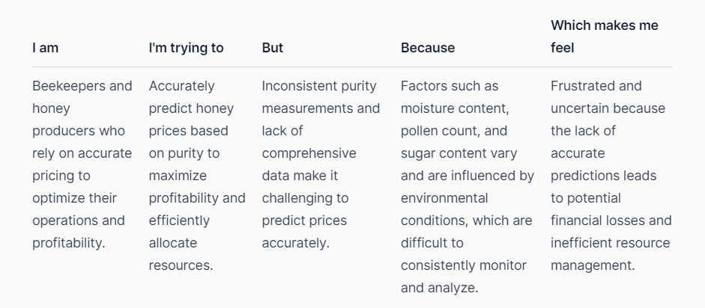

**Example:**

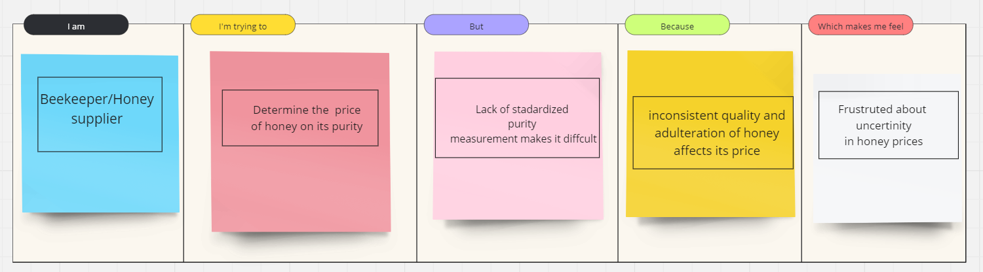

|  |  |  |  |  |  |
| --- | --- | --- | --- | --- | --- |
| **Problem**  **Statement (PS)** | **I am**  **(Customer)** | **I’m trying to** | **But** | **Because** | **Which makes me feel** |
| PS-1 | A beekeeper who produces honey | Get a fair price for my high-quality honey | Can't determine the purity level of my honey. | I Don't know how to measure the purity. | Frustrated about underpricing my honey. |
| PS - 2 | A honey supplier who sources from beekeepers | Source high-quality honey at a fair price | Can't ensure the purity level of the honey I source | I Don't know how to verify the purity claims | Concerned about the quality of the honey I supply. |
| Ps-3 | A consumer who buys honey | Buy high-quality honey at a fair price | Can't determine the purity level of the honey I buy. | I Don't know how to check the purity. | Uncertain about the quality of the honey I consume. |